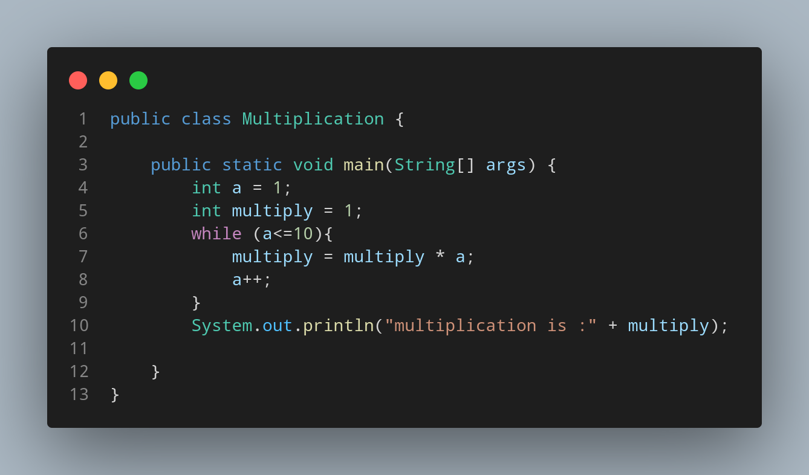

#Doc

File name Multiplication is created so we create a class name Multiplication, inside the class we created a main function.Inside main function we created two variable, a and multiply both having integer data type. First we assigned a=1 and multiply=1 as a defult value.Using while loop until a is greater that 10 , we looped our multiplication program (where multiply variable and a are multiplied with each other and stored in same multiply variable). In each loop we increased our value of a by 1.

Lets see how this program work →

a = 1
multiply = 1

a can’t be more than 10 .. so loop starts

now multiply = 1 * 1 = 1

a++ now a = 2

repeat the loop

now multiply = 1 * 2

a++ now a = 3 and multiply = 2

repeat the loop until a = 10 then the condition dosn’t meet and loop ends.

Finally we print out our total data stored inside multiply.

